SPRINT – 2
Conditional Statements
- If…else (2 conditions)
- Elif (3 or more conditions) – better because it ignores the remaining conditions once the ‘true’ one is found
- Else – catches anything that isnt caught by the preceding conditions i.e. the conditions before it were ‘false’; provides a default action; comes at last
- Shorthand if – if only 1 statement to execute, can put it on the same line as the if statement, but still need the colon after it
- Shorthand if else – value_if_true if conditon else value_if_false, aka ternary operator/conditional expression

Logical Operators
- Used to combine conditional statements
- 3 logical operators: and, or, not
- And: returns true if both statements are true
- Or: returns true if one of the statements is true
- Not: reverses the result, returns false if the result is true
- Precedence: not->and->or
age =25
is_student = false
has_discount_code = true
Eg. : if(age<18 or age>65) and not is_student or has_discount_code

- Truth tables: understanding of how logical operators work with diff values
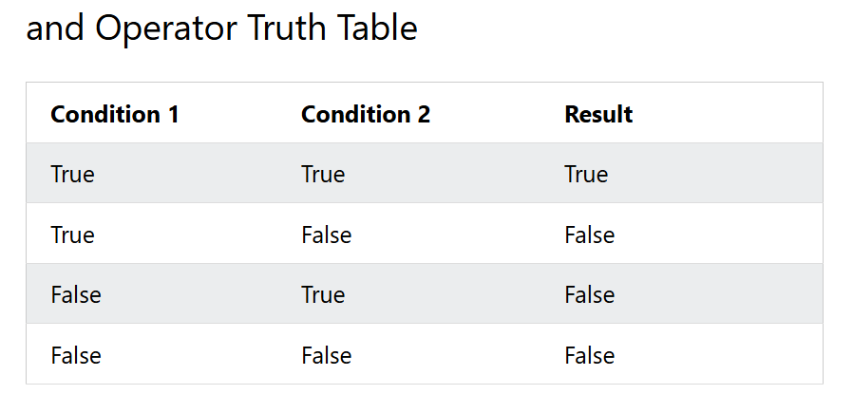
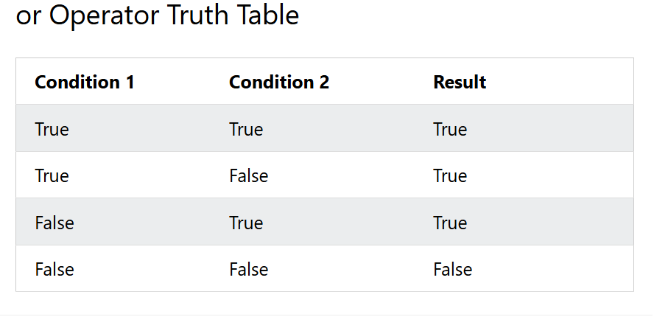
- Nested if – if statement inside another if statement.
Inner if statement only runs if the outer if condition is true.

Use as per need: Nested if statement: when the second condition depends on the first to be true and we need true/false checks at multiple levels

Logical operators: when we need all the conditions to be true at the same time.

Compilation error:
Happens when computer program cannot translate source code into an executable file because the code breaks the rules or structure of the programming language

Match statement
Instead of writing many if…else statements, we can use the match statement
Match selects one of the many code blocks to be executed

Loops
- While – can execute statements as long as the condition is true; keep in mind to increment ‘i”, or the loop will execute forever.

- For – used for iterative over a sequence (list, tuple, dictionary, set, string).
Range() function in for loop is used to loop through a set of code a specified no of times. Must always specify an ending value, starting value as needed. Specifiying increment value by using a third parameter is optional as well.

** Else – with while & for statement, else can be used along with it once when the condition is no longer true/loop is finished. It will not be executed if the loop is stopped by a break statement.

Looping statements
- Break – skips the entire loop once when the condition is met(True)
- Continue – skips the current block of code but executes the remaining part of the loop
- Pass – when we need to write a statement syntactically and it cant be empty, we use “pass” to avoid getting an error ; or the part which we might want to change/update later ; is a null operation -> nothing happens when python executes it, serves as a placeholder.
Can be used with if-elif-else, while and for loops

Difference between pass and comments:
- Comments get ignored by python
- Pass is actual statement that gets executed

